**Initial Design**

In the initial design phase, we considered a straight-arm mechanism with a pivot positioned at the back of the robot and another pivot located near the end of the arm. This design seemed suitable due to its simplicity and stability, making it relatively straightforward to construct.

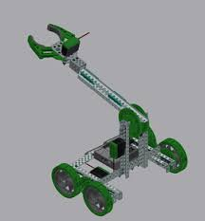

An alternative concept involved a multi-stage lift; however, we ultimately decided against this approach. A multi-stage lift presented several challenges, including decreased stability, a greater number of potential failure points, and limitations associated with sprocket availability and chain length.

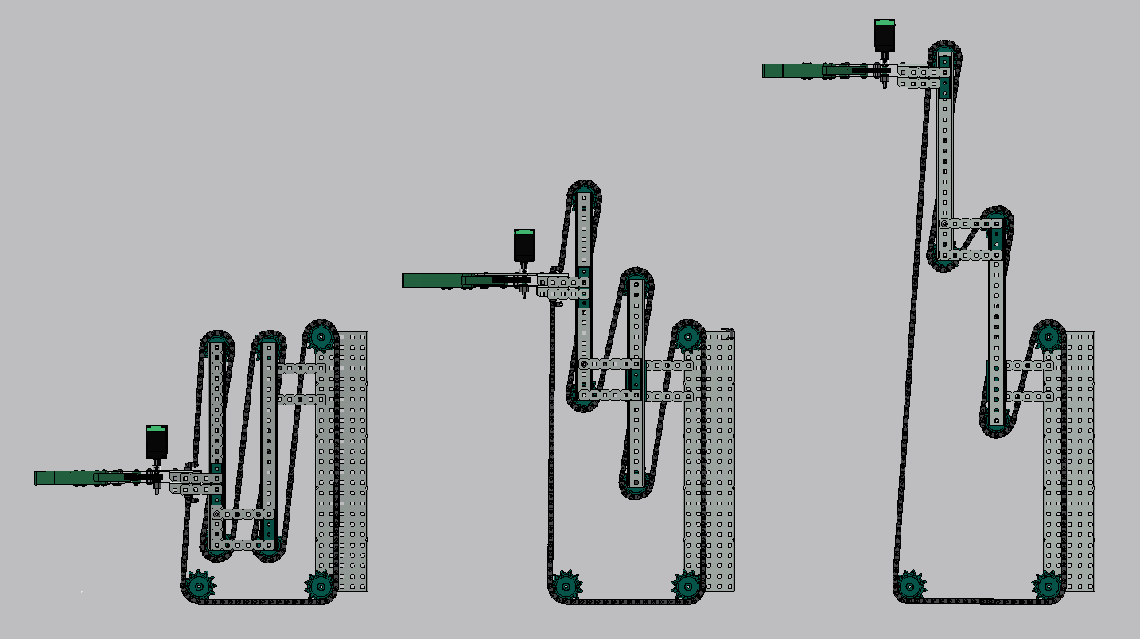

**Initial Drawing and Challenges**

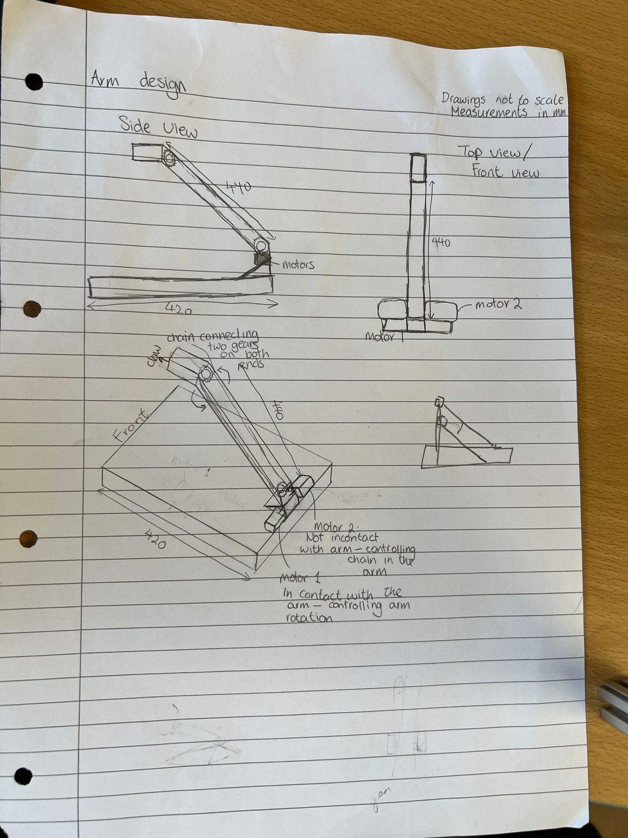

Our initial drawing reflected our first concept, but we identified several problems with the design:

* The reach was limited as the robot had to fit within a ~45 cm box, and the arm could not extend beyond this constraint.
* The use of chains and sprockets introduced additional points of failure.
* The entire arm was to be powered by a single motor, which might not have been strong enough to support its movement.
* There was no room for implementing gear ratios to control speed.
* The design did not provide a suitable method for attaching the arm securely to the robot’s main body.

**Redesign and Improvements**

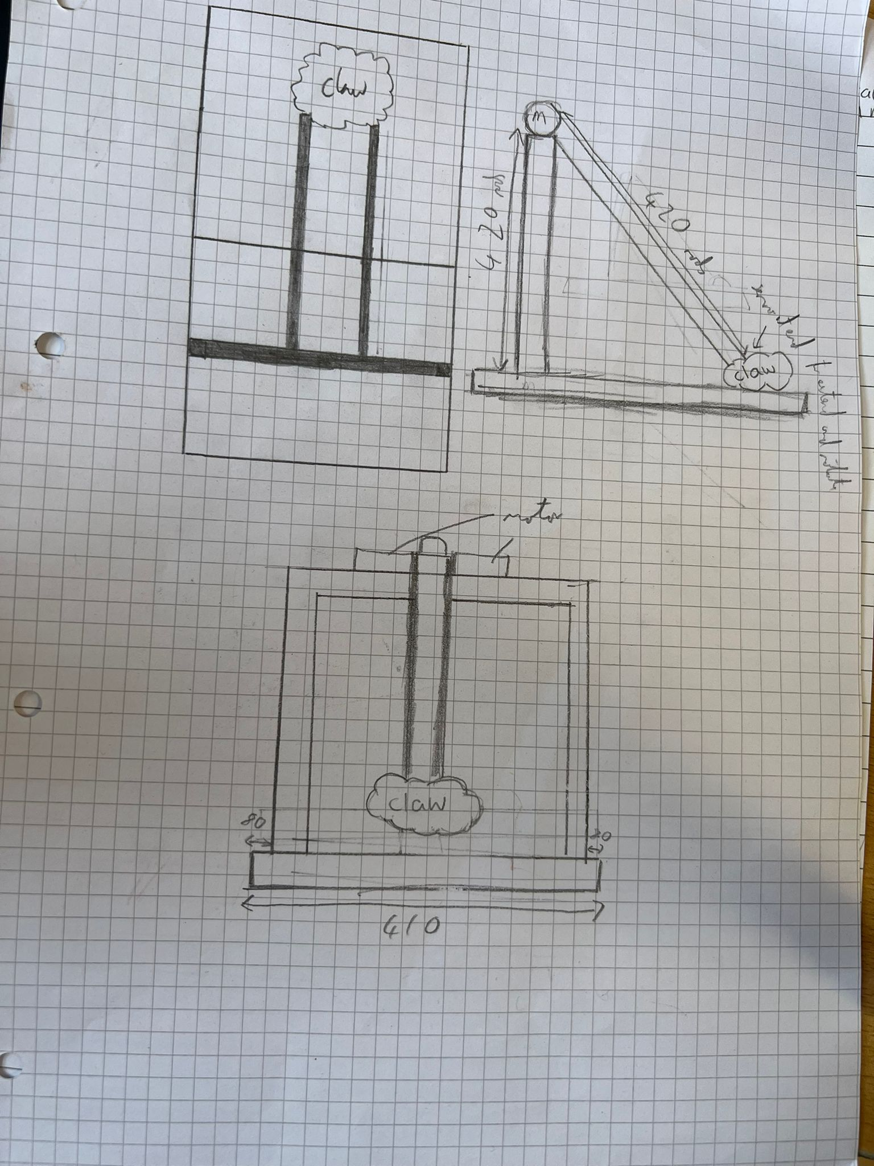

To address these issues, we redesigned the arm and eliminated the joint along the arm, instead mounting the arm to the top of a vertical frame on the robot. This approach had several benefits:

* Improved attachment to the robot’s main structure.
* Increased reach.
* The use of both motors to rotate the main arm, which should be strong enough.
* Removal of the chain and sprockets, reducing potential failure points and simplifying implementation.

However, the redesign also introduced some potential drawbacks:

* A higher centre of mass, increasing the risk of tipping.
* Reduced manoeuvrability due to the loss of the mid-arm joint.
* Possible difficulty in effectively picking up blocks due to angle of the arm.

**First Prototype**

Our first prototype features a modified gear system instead of a bar across the top, we implemented an axle connected to the arm with large gears, paired with another axle connected to the motors using smaller gears that mesh with the larger gears. This configuration allows us to reduce motor speed while increasing torque.

**Challenges Encountered**

During the construction of the prototype, we faced several challenges:

* Ensuring proper alignment of axles, motors, and gears was difficult. We resolved this by using multiple spacers, significantly minimizing movement.
* One of the small gears was skipping teeth as it was not meshing properly with the larger gear because it was slightly further away than the gear on the other side – this led to the arm having a slight roll, and we fixed this by moving the axel up on that side.

**Potential Issues**

Despite these improvements, the prototype still presents some concerns:

* There is nothing to stop the arm from rotating completely around which if uncontrolled could tangle it in the motor wires. Also, the teeth could slip and strip the gears.
* The arm’s height exceeds the desired limit, measuring 45 cm, which may necessitate further modifications to ensure compliance with size constraints and stability requirements.